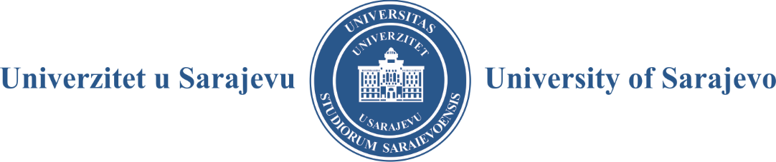

1 E - FORM
Obtaining University
Consent for Publishing University Edition in Electronic Form

The Organizational Unit’s Council or Publishing Committee, at its session of , decided to candidate the issuing/reprint/reissue of the following special purpose publication:

GENERAL DATA
1 | UNSA MEMBER INSTITUTION  (Faculty/Academy/Institute /Joined Institution or Sub-Organizational Unit)
 | NAME
 | DEAN /DIRECTOR
2 | PUBLICATION
 | Author’s name and surname
 | Publication’s title
 | Publication type:
 | - textbook
 | - monograph
 | - scientific book
 | - practicum
 | - coursework
 | - manual
 | The publication - textbook is intended for the following:
 | - study program and study cycle
 | - term
 | - number of lessons
 | The publication includes the subject:
 | - course material (in %)
 | The publication also includes the following subjects’ course material:
 | - course material (in %)
 | - course material (in %)
3 | REVIEWERS (two minimum)
 | - name and surname, teaching/scientific title
 | - home institution
 | - expertise area
 | - name and surname, teaching/scientific title
 | - home institution
 | - expertise area
 | The publication will be published in open access under a 4/0 Creative Commons license on the following website: www.ebooks.unsa.ba

Attachments:
- Manuscript of the nominated work and electronic form;
- Decision on the reviewers nomination;
- Manuscript of reviews;
- Statement by the author on the manuscript originality;
- Curriculum of subjects covered by the publication (for textbooks);
- A payment slip copy of 200,00 BAM;.
Note: These contributions must be submitted to the Publishing Council, so they should meet the requirements prescribed by the Publishing Council Rules of Procedure, Instructions for Manuscript Proposers, Instructions for Reviewers, Instructions for University Publications Authors and the Rulebook on Publishing at the University of Sarajevo.
The manuscript proposer’s competent department is obliged to confirm whether the proposed documentation has been prepared in accordance with the given procedures by the University of Sarajevo Publishing Council..

Incomplete applications will not be considered and will be returned to the applicant.

Place and Date

DEAN/DIRECTOR

______________________ M. P.

