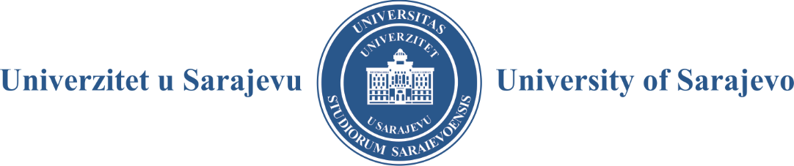

ORGANIZATIONAL UNIT NAME:

ADDRESS:

CONTACT:

AUTHOR'S STATEMENT ON THE MANUSCRIPT ORIGINALITY
(for e-editions)

I/We hereby declare and confirm under full criminal accountability and liability for damage that the entire manuscript as well as parts of manuscript under the title produced by me /we is original authorship work, previously not published in any way, shape or form. Hereby the consent that manuscript can be published in free access on the platform www.ebooks.unsa.ba has been granted as well.

Mine/our own signature/s on this document is/are hereby to certify that.

In Sarajevo, YYYY

STATEMENT GIVEN BY AUTHOR/GROUP OF AUTHOR'S:

______________________________

______________________________

______________________________

This document must be certified by the competent administrative body.

